

**West Japan Model United Nations III**

*Invitation Handbook*

2022-2023

Welcome to the 3rd annual WJMUN conference. We hope this academic experience will serve to be fulfilling and engaging for your students. This handbook consists of general information for the third annual WJMUN conference. We have included the guidelines from our previous conferences and additional information regarding the in-person structure we will run this year.

**Please refrain from distributing this handbook to those who are not involved with this event without the organizers’ consent.**

Created by:

Marin Suzuki, WJMUN III, Main Organizer

Supported by:

Isa Jaro, WJMUN III, Secretary/Co-Organizer

Johan Barth, WJMUN III, Advertisement/Co-Organizer

Jiaxu Zhao, WJMUN III, Communications

Miyu Lee, WJMUN III, Communications

Alexander Kameoka, WJMUN III, Communications

Jiwon Lee, WJMUN III, Hosting

Souma Eguchi, WJMUN III, Hosting

Zhen Zhuo Li, WJMUN III, Finance

Shunsuke Endo, WJMUN III, Finance

Haruto Shimpo, WJMUN III, Technology

# 

**Table of Contents**

Registration Processes

Chair Application Processes

Dates and Schedules

Accommodations

Awards

Fees

Contact Information

# 

# 

# 

# 

# 

# 

# 

# 

# **Dates and Procedures**

(Students and staff are expected to arrive on the day prior to the event)

## Friday, April 7th

| JST | Event | Location |
| --- | --- | --- |
| 8:30 AM | Arrival in FIS | Fukuoka International School Annex |
| 9:00 AM ~ 9:20 AM | Opening Ceremony | Respective Committee rooms |
| 9:20 AM ~ 11:00 AM | First Session | Respective Committee rooms |
| 11:00 AM ~ 11:15 AM | Break | On-Campus |
| 11:15 AM ~ 1:15 PM | Second Session | Respective Committee rooms |
| 1:15 PM ~ 2:15 PM | Lunch | Cezars Lunch provided by FIS |
| 2:15 PM ~ 4:00 PM | Third Session | Respective Committee rooms |

## 

## Saturday, April 8th

| JST | Event | Location |
| --- | --- | --- |
| 8:30 AM ~ 11:00 AM | First Session | Respective Committee Rooms |
| 11:00 AM ~ 11:15 AM | Break | On-Campus |
| 11:15 AM ~ 12:30 PM | Second Session | Respective Committee Rooms |
| 12:30 PM ~ 1:30 PM | Lunch | Restaurants Provided by Tourism Department |
| 1:30 PM ~ 4:00 PM | Third Session | Respective Committee Rooms |

## 

## Sunday, April 9th

| JST | Event | Location |
| --- | --- | --- |
| 8:30 AM ~ 10:45 AM | First Session | Respective Committee Rooms |
| 10:45 AM ~ 11:00 AM | Break | On-Campus |
| 11:00 AM ~ 1:30 PM | Second Session | Respective Committee Rooms |
| 1:30 PM ~ 2:30 PM | Lunch | Restaurants provided by Tourism department |
| 2:30 PM ~ 3:00 PM | Closing Ceremony | Fukuoka International School Gym |

# Registration Processes:

*This year WJMUN is accepting SCHOOLS (not individuals) locally and internationally. Please sign up for this event via google forms for our team to learn more about your school.*

*DISCLAIMER: For ALL schools, a* ***school staff member*** *as a* ***chaperone MUST*** *attend the trip with the students.*

# Travel:

[**BROCHURE OF FUKUOKA**](https://www.canva.com/design/DAFFg3qhnD0/BD4CU99zdabtmI3m5cTudA/edit?utm_content=DAFFg3qhnD0&utm_campaign=designshare&utm_medium=link2&utm_source=sharebutton)

Access:

Address of Fukuoka International School:

3-18-50 Momochi | Sawara Ward

Fukuoka 814-0006 Japan

T: +81-92-841-7601

From Fukuoka Airport:

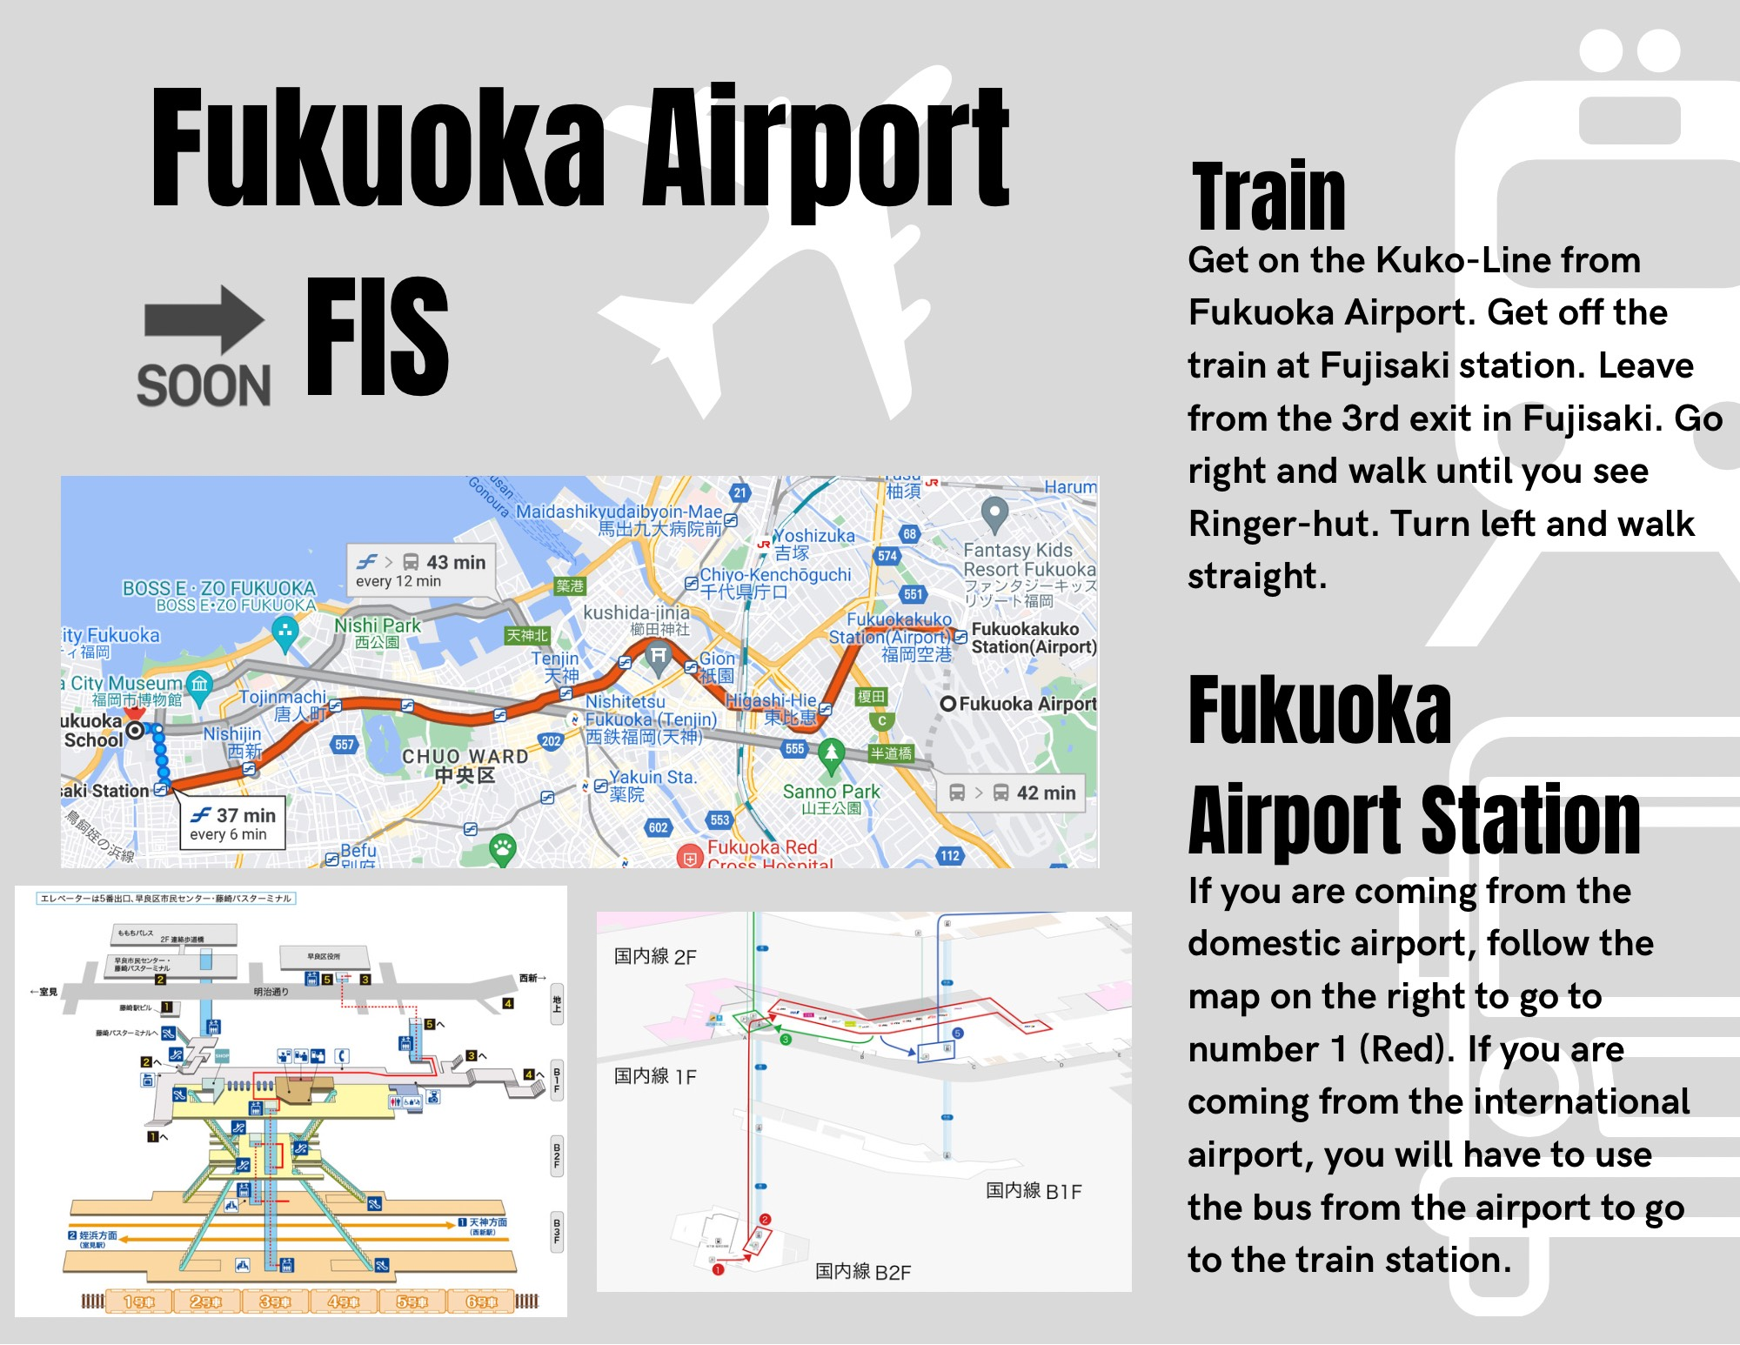

Cost: 300 YEN

Venue

3rd Floor: 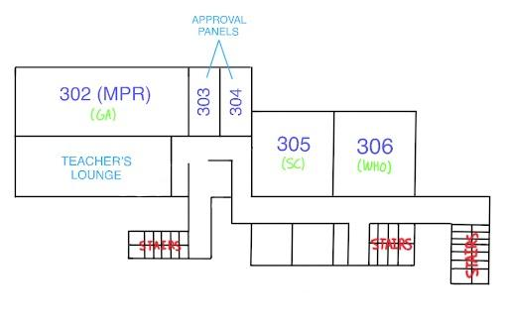

4th Floor:

# 

# Accommodations:

*The following information is limited to those who will be staying at FIS during the three nights. Schools have the option to book nearby hotel rooms for their students individually, or can choose to stay at FIS. However, schools must notify the WJMUN beforehand so that the team can keep track of who will be staying.*

*FIS will be providing futons to students at an approximate price of* ***3500 yen/person****; this will be a* ***one-time cost*** *and the futons will be used for all three nights. (Prices may vary depending on the number of students)*

Doors (Doors all open during the day and until FICS leaves on Friday night):

* Main Door (Main Building): locked at 9:30 PM
* Side Automatic Door (Main Building): Open all night
* Main Door (West Building): Open all night

Student Showers:

* Located in the GYM
  + Girls’ Showers: corner of the gym
  + Boys' Showers: left side of the girl's shower

*Mask use will be optional throughout the delegate’s stay at FIS*

Overnight in Classrooms

**Night**

* Remove shoes before entering classrooms
* Return to school no later than 23:00 PM
* Do not roam around the school at night. Stay in your allocated rooms.
* Do not touch any of the resources in the classrooms.

**Departure**

Please make sure all of the following is completed before you leave on the third day:

* Rooms and tables are put back the way you found them.
* All rubbish is put into a bag provided and brought down to the lobby.
* The futons are put away neatly and placed back where you found them.

# Meals

Breakfast:

| Friday | 6:45 AM - 7:30 AM | Lower Lobby and Upper Lobby |
| --- | --- | --- |
| Saturday & Sunday | 7:45 AM - 8:30 AM | Lower Lobby and Upper Lobby |

Lunch:

Friday

| JST | Event | Location |
| --- | --- | --- |
| 8:30 AM ~ 11:00 AM | First Session | Respective Committee Rooms |
| 11:00 AM ~ 11:15 AM | Break | On-Campus |
| 11:15 AM ~ 1:15 PM | Second Session | Respective Committee Rooms |
| 1:15 PM ~ 1:35 PM | Lunch (General Assembly) | Cezars Kitchen |
| 1:35 PM ~ 1:55 PM | Lunch (HRC + SC) | Cezars Kitchen |
| 1:55 PM ~ 2:15 PM | Lunch (WHO + ECOSOC) | Cezars Kitchen |
| 2:15 PM ~ 4:00 PM | Third Session | Respective Committee Rooms |

Saturday

| JST | Event | Location |
| --- | --- | --- |
| 8:30 AM ~ 11:00 AM | First Session | Respective Committee Rooms |
| 11:00 AM ~ 11:15 AM | Break | On-Campus |
| 11:15 AM ~ 12:30 PM | Second Session | Respective Committee Rooms |
| 12:30 PM ~ 12:50 PM | Lunch (General Assembly) | Cezars Kitchen |
| 12:50 PM ~ 1:10 PM | Lunch (HRC + SC) | Cezars Kitchen |
| 1:10 PM ~ 1:30 PM | Lunch (WHO + ECOSOC) | Cezars Kitchen |
| 1:30 PM ~ 4:00 PM | Third Session | Respective Committee Rooms |

Sunday

| JST | Event | Location |
| --- | --- | --- |
| 8:30 AM ~ 10:45 AM | First Session | Respective Committee Rooms |
| 10:45 AM ~ 11:00 AM | Break | On-Campus |
| 11:00 AM ~ 1:30 PM | Second Session | Respective Committee Rooms |
| 1:30 PM ~ 1:50 PM | Lunch (General Assembly) | Cezars Kitchen |
| 1:50 PM ~ 2:10 PM | Lunch (HRC + SC) | Cezars Kitchen |
| 2:10 PM ~ 2:30 PM | Lunch (WHO + ECOSOC) | Cezars Kitchen |
| 2:30 PM ~ 3:00 PM | Closing Ceremony | Fukuoka International School Gym |

Snacks and Drinks:

Cezars will be serving snacks and drinks in the Annex for students to eat during their break time.

# 

# Sleeping Area:

**Boys sleeping rooms**

405 - United World College

403/4 - Surabaya Intercultural School

**Girls sleeping rooms**

305 - United World College

306 - Surabaya Intercultural School

**Teachers sleeping rooms**

* 214, 215
* 303, 304
* Lounge, MPR
* 402

**Team Storage rooms - Girls**

303 United World College

304 Surabaya Intercultural School

**Team Storage rooms - Boys**

402 United World College

4th floor Japanese office - Surabaya Intercultural School

**Accommodations 2: Suggested Hotels**

* [シーサイドホテルツインズももち](http://www.ihwgroup.co.jp/): About 4900-6600 yen/person, 17min walk from our school

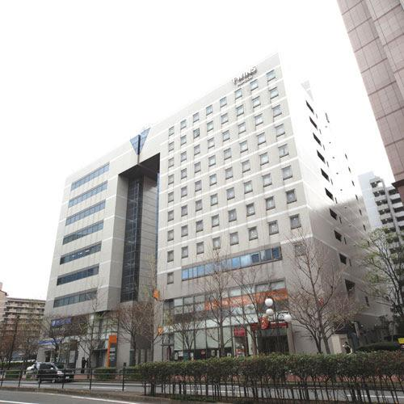

* [ザ・レジデンシャルスイート・福岡](https://www.trs-fukuoka.co.jp/#_ga=2.245838914.779633405.1667615885-102084738.1667615885): About 5500 (if multiple people stay in the same room) - 9000 yen/person, 16min walk from our school (medium price range)

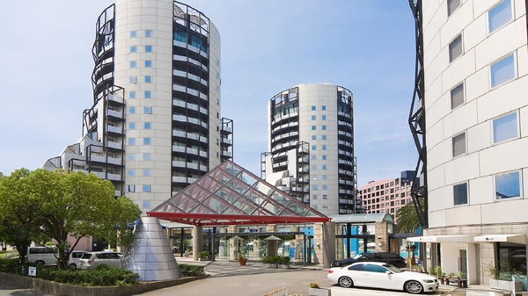

You can see some more options [here](https://www.google.com/travel/search?q=hotels%20near%20fukuoka%20international%20school&g2lb=2502548%2C2503771%2C2503781%2C4258168%2C4270442%2C4284970%2C4291517%2C4306835%2C4597339%2C4718358%2C4723331%2C4731329%2C4757164%2C4814050%2C4816977%2C4821091%2C4852066%2C4861687%2C4864715%2C4865467%2C4878223%2C4878226%2C4878644%2C4885157%2C4886479%2C4887074%2C4892547%2C4893075&hl=en-JP&gl=jp&cs=1&ssta=1&ts=CAESABocEhoSFAoHCOYPEAsYHBIHCOYPEAsYHRgBMgIQACoHCgU6A0pQWQ&qs=CAE4Bg&ap=KigKEgk6cx9dVMlAQBE56KNKqkpgQBISCQ3TeawjzEBAETnoo8xUS2BAMABoAQ&ictx=1&ved=0CAAQ5JsGahgKEwiwscPl_pX7AhUAAAAAHQAAAAAQ1QY), though they might be more expensive/further from the school compared to these two.

* [平和台ホテル](https://www.heiwadai-hotel.co.jp/five/)
  1. 和室 (Japanese-style room): 4 people/4475 YEN~
  2. Family room (with beds): 4 people/4875 YEN~
  3. Semi-Double: 2 people/4050 YEN~
  4. Twin: 2 people/4400 YEN~
* [プラスワン藤崎](https://www.plusone1.xyz/)
  1. Triple: 3 people/2200 YEN~

# Awards:

1. Best Delegate

The best delegate is selected by the chairs of the representative committee. The Best Delegate award is given to the delegate who performs, prepares, and is the most knowledgeable in the entire committee.

1. Most Improved Delegate

The Most Improved Delegate award will be given to delegates who show the most significant improvement over the course of the conference.

1. Most Active Delegate

The Most Active Delegate will be determined through the statistics provided by the Nextic app. The delegate who constantly asks POIs to give the most speeches and is the most active during debates will be awarded.

# Fees:

*Participation Fees: 5000 YEN/per school*

# Fukuoka Accommodations:

Restaurants available in Fukuoka

* 中国大明火鍋城, Fujisaki station
* Mark Is (Food court), Tojinmachi Station
* Places to shop
  + Canal city, Hakata station
  + Hakata Station
  + Tenjin, Tenjin station
  + Markis, Tojinmachi station
  + Lalaport Fukuoka, Takeshita Station
  + 藤崎商店街, Fujisaki Station
  + Don Quijote, Nishijin Station
* Sightsee in Fukuoka City
  + 大濠公園, Ohori park station
  + 太宰府天満宮, Dazaifu station
  + Fukuoka Tower, Fujisaki station
  + Momochi beach, Fujisaki station
  + Atago Shrine

# Pre-Debate Information

Delegates are recommended to do pre-debate preparations in order for them to enjoy and participate in the conference fully.

* Thorough research on your assigned country
* Study the WJMUN procedures and debate style
* Review your assigned committee and topic
* It is recommended to read through the chair reports which can be found on our website [WJMUN](https://www.wjmun.org/)
* Prepare an opening speech about 45 seconds
* Prepare clauses to be added to the resolution during lobbying

# **Contact Information**

* *General Organizer*
  + [marin.suzuki24@fis.ed.jp](mailto:marin.suzuki24@fis.ed.jp)
* *Co-Organizer & Secretary* 
  + [mariaisabel.jaro24@fis.ed.jp](mailto:mariaisabel.jaro24@fis.ed.jp)
* *Co-Organizer & Advertisement*
  + [johan.barth24@fis.ed.jp](mailto:johan.barth24@fis.ed.jp)
* *MUN Advisors* 
  + [apook@fis.ed.jp](mailto:apook@fis.ed.jp)
  + [agoad@fis.ed.jp](mailto:agoad@fis.ed.jp)
* WJMUN email
  + [wjmun@fis.ed.jp](mailto:wjmun@fis.ed.jp)